**The Result Shows The Regional Resume Classification System**

**Product Planing Paper**

|  |  |  |
| --- | --- | --- |
| **File status:**  **[ ]Draft**  **[ ]Under revision**  **[ * ]Official release** | **Document identification:** | **Product Planing Paper** |
| **Current version:** | **V1.0** |
| **Document author:** | **Yiyi Duan** |
| **Completion date:** | **2020.04.08** |

|  |  |
| --- | --- |
| **Project team members** | **Students ID** |
| Mingyang Duan | 201930310253 |
| Yue Li | 201930310255 |
| Hengyang Wang | 201930310214 |
| Yiyi Duan | 201930310235 |

1. **Introduction**
   1. **Compiling purpose**

The preparation of this project plan is mainly to make the main planning and integration for the development of resume classification system, to play a guiding role in the development process, to ensure that the project team can complete the project objectives on time and with high quality, so that the project team members can better understand the project situation, so that they can carry out the work of each stage of the project in a reasonable and orderly manner. In the form of documents, make arrangements for the scope of work tasks within the project cycle, task decomposition of various works, organizational structure of the project team, work responsibilities of each team member, development progress, etc. This project plan is the basis of the whole project activity, and also the basis for the project team to carry out and check the project work.

* 1. **Background**

Project Name: resume classification system

Project entrusting unit: Resume classification system development team

Users of the project (unit): Volkswagen

Task proposer: Resume classification system development team

Project construction background: through to use this system, we can provide users with scientific and reasonable resume classification work, improve the work efficiency for some resume processing workers, and fundamentally change the resume management work. Through the system, users can directly classify resumes according to different positions, which provides convenience for the recruitment process. The resume of job seekers will be read accurately in a large number of resumes, which can achieve standardized management, scientific statistics, and rapid query.

* 1. **Definition**

Development environment：

windows10, python3.6, tensorflow1.12, anaconda3, pycharm.

Database：My SQL

1. **Project overview**
   1. **Project objectives**

The goal of the system is to classify the uploaded resumes and return the results through the job positions. The goal of this project is to provide a system that can receive the resumes uploaded by users on the front-end page, upload the resumes to the back-end server, receive the classification results, and provide an interactive interface for users to operate.

The project objectives are as follows:

* Make sure to receive resume correctly and identify file format and coding type accurately
* Ensure the resume received by the front-end page can be transmitted to the back-end server smoothly
* Ensure that the server can accurately identify the type of job application in the resume and give feedback
* Ensure the classification results can be correctly displayed to users
* Ensure that the project objectives are achieved within the specified budget and time
* Ensure the final quality and quantity of products are completed and accepted
  1. **Work content**
  2. Project feasibility analysis
  3. Project demand analysis
  4. Product design book
  5. project planning paper
  6. Project risk plan
  7. Product test plan and test report
  8. Complete product code
  9. Complete test code
  10. **Main participants**

Project Leader: Duan Mingyang

Has strong organization and management ability

System Analyst: Duan Mingyang, Li Yue, Wang Hengyang, Duan Yiyi

Team completed the cooperation and comprehensive analysis

Developer: Duan Mingyang, Li Yue, Wang Hengyang, Duan Yiyi

In charge of each module. Have strong programming ability

Tester: Duan Mingyang, Li Yue, Wang Hengyang, Duan Yiyi

Team completed the cooperation and comprehensive analysis

Simulation client: Duan Mingyang, Li Yue, Wang Hengyang, Duan Yiyi

Working together, with strong observation ability

* 1. **Acceptance criteria**

All functions of the system operate normally, meeting the requirements of demand analysis and product design.

1. **Work plan**
   1. **Communication plan**

**External coordination:**

Through the communication with the teacher, we should understand the task content in time, and correct the mistakes and deficiencies pointed out by the teacher in time.

**Internal communication:**

Weekly meeting

Meeting time: after the end of each week course.

Purpose of the meeting: the group plans during the meeting, coordinates its daily activities, reports and discusses obstacles encountered.

Meeting members: all members of the team

Meeting time: 30-60min

Meeting form: online discussion during the epidemic and face-to-face meeting after returning to school

* 1. **Work breakdown structure**

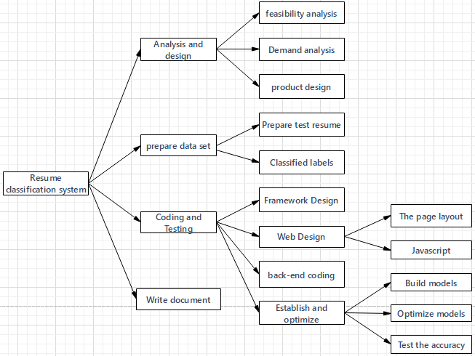

* 1. **Schedule plan**

Release plan

|  |  |  |
| --- | --- | --- |
| sprint | content | Milepost |
| 1 | project planning paper  Product design paper | 3.26-4.10 |
| 2 | Project risk plan  Product test plan and test report  Complete product code  Complete test code | 4.11-5.01 |
| 3 | Improved product code  Improved test code  Summary report  Speech PPT | 5.02-5.08 |

Gantt chart

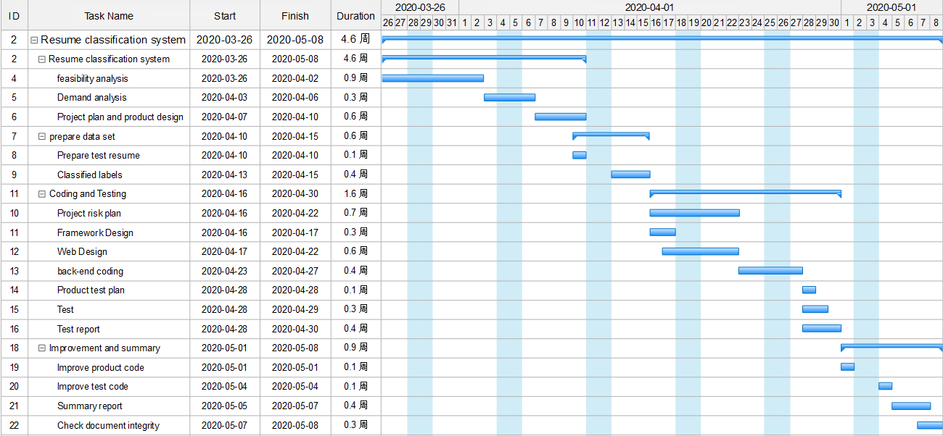

* 1. **Project control plan**

**3.4.1 Quality assurance plan**

All systems are implemented in accordance with the project plan, documents generated during the period are stored uniformly, and existing facilities are used for hardware facilities.

**3.4.2 Schedule control plan**

All should be implemented according to the overall schedule.

**3.4.3 Budget monitoring plan**

The funds should be uniformly controlled and the use of funds should be recorded.